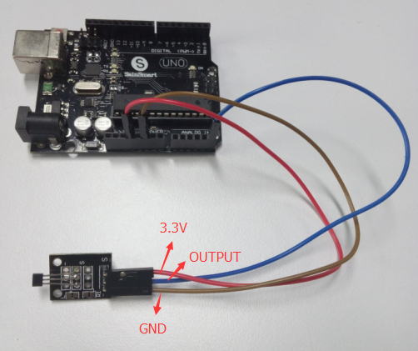

int sensorPin = A5; // select the input pin for the potentiometer

int ledPin = 13; // select the pin for the LED

int sensorValue = 0; // variable to store the value coming from the sensor

void setup() {

pinMode(ledPin, OUTPUT);

Serial.begin(9600);

}

void loop() {

sensorValue = analogRead(sensorPin);

digitalWrite(ledPin, HIGH);

delay(sensorValue);

digitalWrite(ledPin, LOW);

delay(sensorValue);

Serial.println(sensorValue, DEC);

}